**Registration Form**

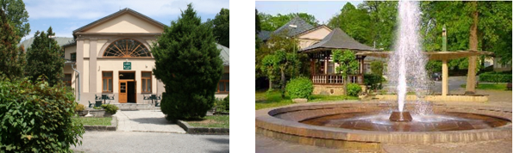

**Application**  *paper with participation in the conference*

*paper without participation*

***Participant’s affiliation***

Kliknite alebo ťuknite sem a zadajte text.

***Participant’s name and surname***

Kliknite alebo ťuknite sem a zadajte text.

***Contact address*:**

**- *phone / fax* - *e-mail***

Kliknite alebo ťuknite sem a zadajte text.Kliknite alebo ťuknite sem a zadajte text.

**- *street / zip / city***

Kliknite alebo ťuknite sem a zadajte text.

***Identification number of the institution (IČO, DIČ, BIN, TAX-ID, VATIN)***

Kliknite alebo ťuknite sem a zadajte text.

***Paper title in English***

Kliknite alebo ťuknite sem a zadajte text.

***Key words***

Kliknite alebo ťuknite sem a zadajte text.

***Co-authors***

Kliknite alebo ťuknite sem a zadajte text.

***Accommodation***

06.09. – 07.09. 2023

07.09. – 08.09. 2023

***This document should be submitted*** *by* ***June 30th, 2023*** *to e-mail* [***protechma@tuke.sk***](mailto:protechma@tuke.sk)

*Underline (mark) suitable*

***The preliminary abstract should be attached as a separate file*** *(abstract_temp.doc)*

Note: By registering, you agree that all information provided by you can be used by the Organizing Committee. The Organizing Committee reserves the right to use any photograph/video taken at the PROTECHMA 2023 Conference, without the expressed written permission of those included within the photograph/video.